Tutorial 7: Robot Framework for Automated Testing
In this tutorial, you will be using Robot framework to do automated testing
Robot Framework is a generic open source automation framework for acceptance testing, acceptance test driven development (ATDD), and robotic process automation (RPA). It has simple plain text syntax and it can be extended easily with generic and custom libraries.
More information on Robot Framework can be found in the links below:
- https://robotframework.org/
- https://github.com/robotframework/robotframework
Setup
- Install robot framework. Information can be found at: https://pypi.org/project/robotframework/
If you already have Python with pip installed, you can simply run:
pip install robotframework

- Install SeleniumLibrary and WebDrivers. Information can be found at http://robotframework.org/SeleniumLibrary/
- pip install --upgrade robotframework-seleniumlibrary
- pip install webdrivermanager

- After installing, we need to ensure that the tools are properly installed. Bring up the command prompt, simply type “cmd” in Windows search box and then type the following commands:
  - python --version
  - pip --version
  - robot --version
  - chromedriver --version
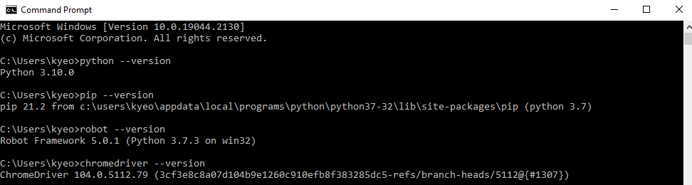

- If you are having trouble with the chromedriver, try this:
  - Start by downloading the chrome driver: https://chromedriver.chromium.org/downloads
You can check your chrome version using this command “chrome://settings/help”
  - Choose a chromedriver that suits your operating system. For windows machine, the chromedriver_win32.zip file works fine for a 64-bit windows machine.
  - Put this chromedriver .exe file in a directory that can be accessed (e.g. “C:\Python310\Scripts\”.
  - Now you need to set the environment variable to point to this chromedriver file.
    - Go to Control Panel -> System -> Edit the system environment variables
    - Click on environment variables
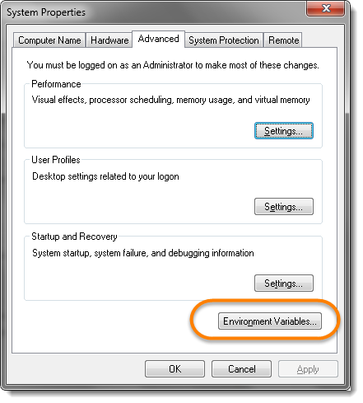
    - Under system variables, select the Path option and click on Edit
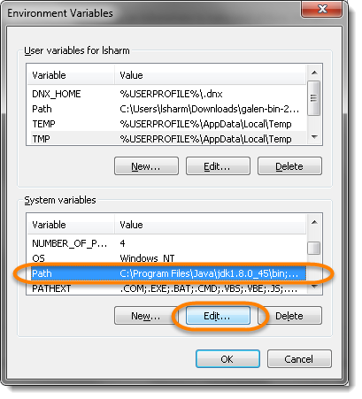
    - Click New and paste the path of your chromedriver .exe file and click OK.
  - If later on (part C), you are prompted with chromedriver and path issue and you could not resolve the issue, maybe try other webdriver such as geckodriver for Firefox.
Getting Started
- Setup your local server running the Login Registration System (from Tutorial 6.2).
- You will need XAMPP: https://www.ionos.com/digitalguide/server/tools/xampp-tutorial-create-your-own-local-test-server/
- The PHP file: Login Registration System (https://code-projects.org/login-registration-system-in-php-with-source-code/)
- Follow through step 1 to 9.
- Lastly, you will still need to make changes to two column names.
  - Go to http://localhost/phpmyadmin/
  - Click on php > users > Structure
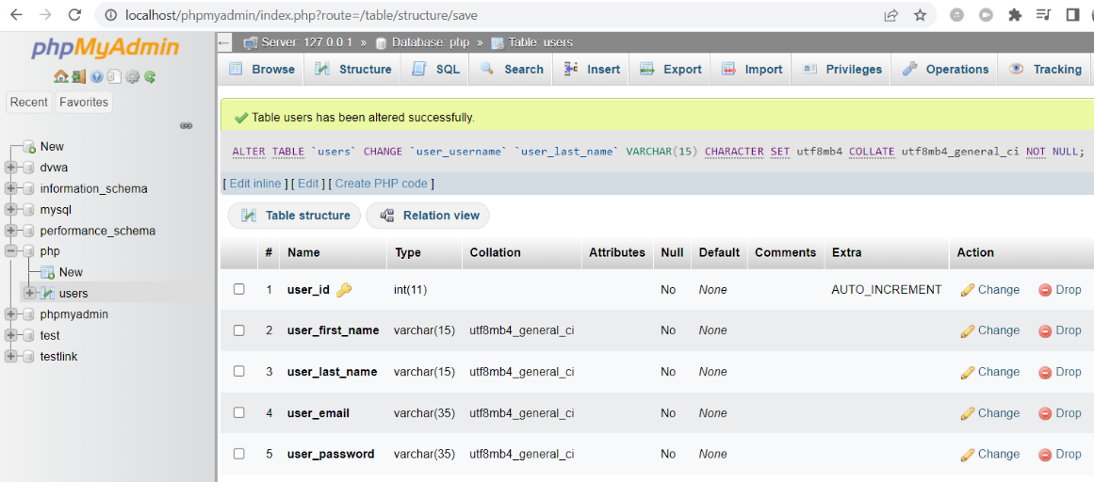
user_name
user_username
  - Change “user_first_name” to “user_name” and click save
  - Change “user_last_name” to “user_username” and click save
  - Look at the video link: https://youtu.be/vIdpSjba_qo for references if needed.
Now we are ready and we can start to use Robot framework to conduct automated testing for this login registration system.
- A robot file contains 4 sections:
- *** Settings *** – Used for Importing test libraries, resource files and variable files.
- *** Variables *** – Used for defining variables that can be used elsewhere in the test.
- *** Test Cases *** – Used for writing our tests.
- *** Keywords *** – Used for creating custom keywords from existing lower-level keywords.
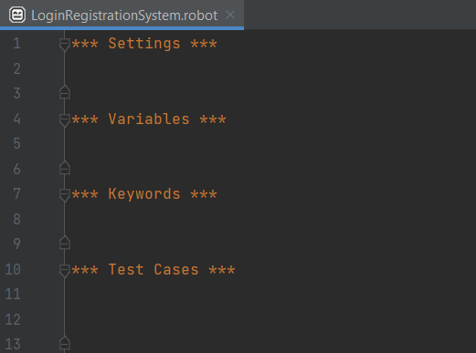

- We will explore these 4 sections slowly. First start up Python and create a new folder “Robot”. Next, create a new file “LoginRegistrationSystem.robot”
  - Type the following into this new file:
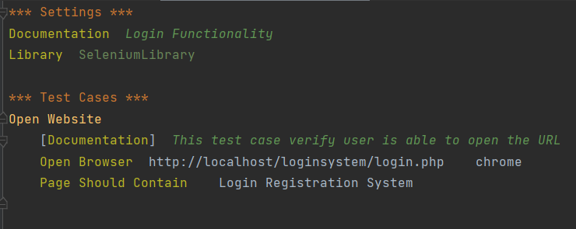
In the above example, we have created a test case called “Open Website” to open a browser and check that it contains certain text. And since we are using Selenium Library, we will be referring the Selenium Library Docs to get the commands used in our tests. One thing to remember is that there should always be a gap of 2 spaces between the functions in Selenium and the keywords.
- Settings:
  - Documentation – These texts are added to the HTML reports to make them more descriptive.
  - Library – import selenium library
- Test Cases:
  - Documentation – Provides more info regarding the test cases. They are also added to the HTML reports generated by Robot.
  - Open Browser – opens the URL in chrome browser
  - Page should contain – verify that the webpage contains certain words
  - If you are not seeing the different colours as shown in the picture above, try downloading the extension “robot framework language server”.
  - To execute the tests, we run the command:
robot -d results LoginRegistrationSystem.robot
Creates a folder called ‘results’ to store the html files

- You should see that the URL was automatically opened, and it brings you to the login page.
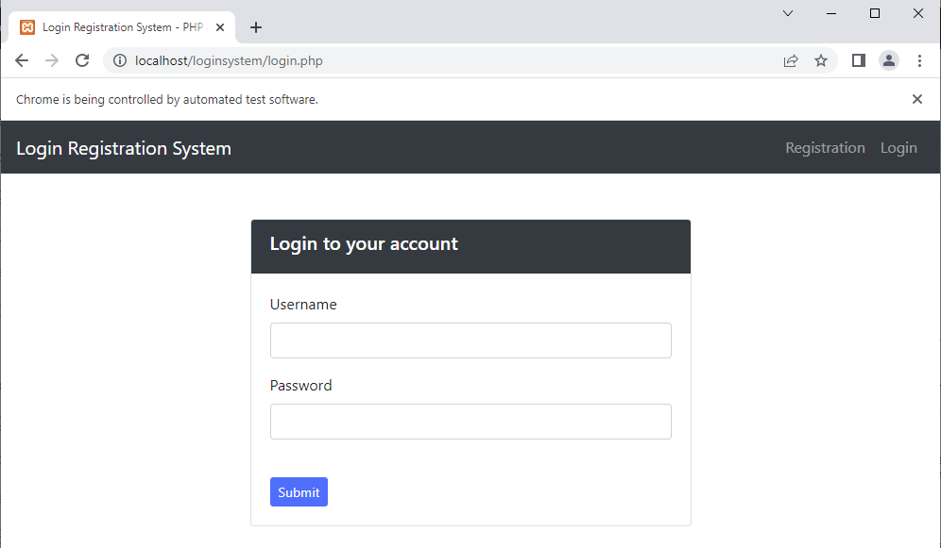
  - You should see the following with 1 test case passed. 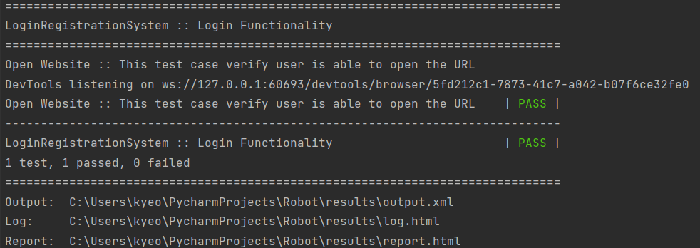
3 html reports
  - You can view the 3 html reports from the link shown. The three files are log.html, output.xml and report.html.
- Open the report.html:
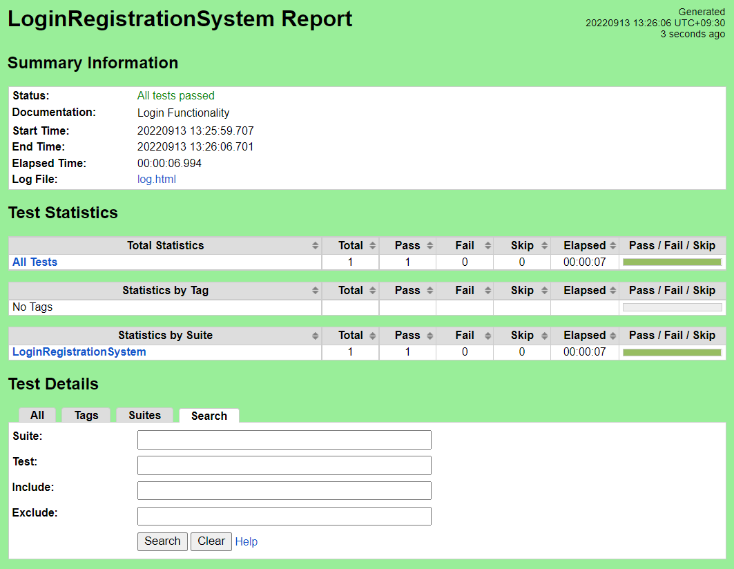
Text from documentation in settings

Click on LoginRegistrationSystem and you can look at the test details:
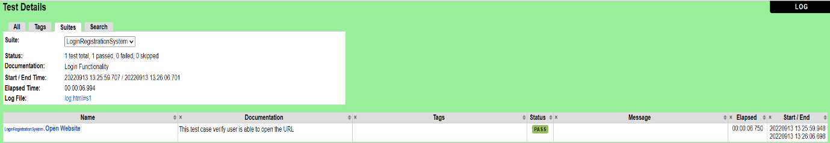

Click on Open Website and you can look at the log:
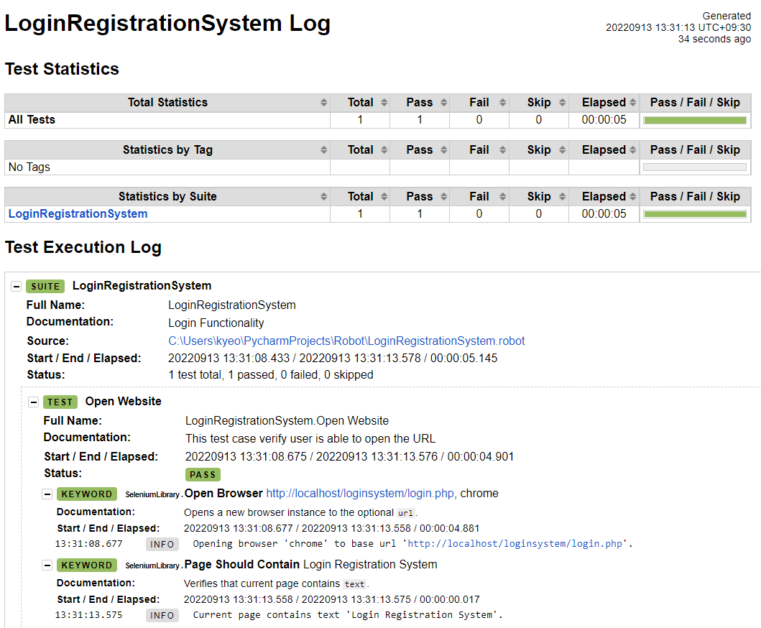
- Now, let us explore the use of variables. There are 4 types of variables in Robot Framework. What is shown below is the most common way to use variables in Robot Framework test data: scalar variable ${variable}. When this syntax is used, the variable name is replaced with its value as-is. More information about other types of variables can be found at: https://robotframework.org/robotframework/latest/RobotFrameworkUserGuide.html#variables
  - Add *** Variables *** into your file with the following details.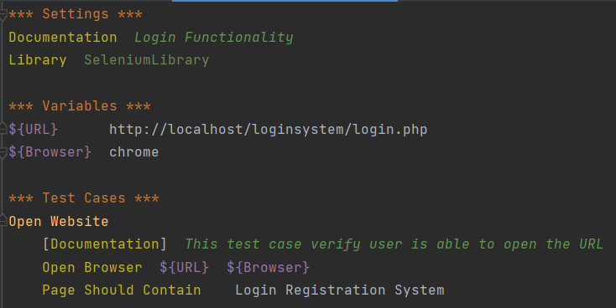
  - Verify that the test case also passed after running it.

- Now, let us first create an account manually with the password: test1pw
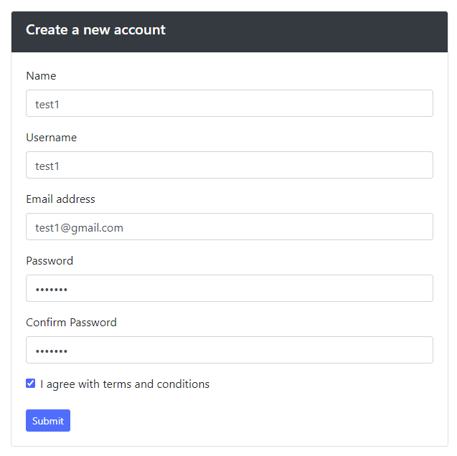

  - Next, we can add a second test case “login to your account”. There are three things to do here:
- Input the username which is “test1”
- Input the password which is “test1pw”
- Click the button “Submit”
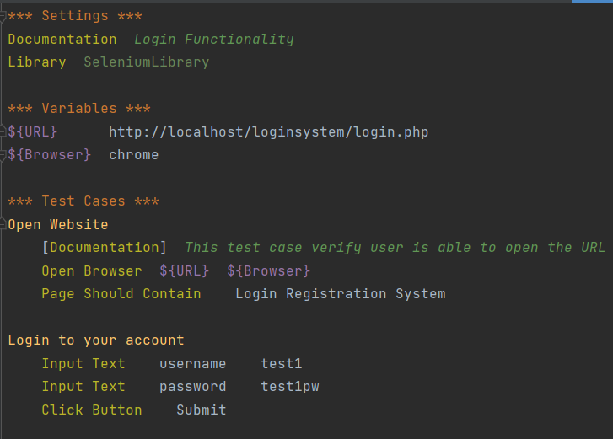
  - Input Text types the given text into the text field identified by locator. It has the syntax:

  - To identify the name of the locator, we can place our mouse cursor in the username textbox, right click and select inspect. The name of the locator is username in this case.
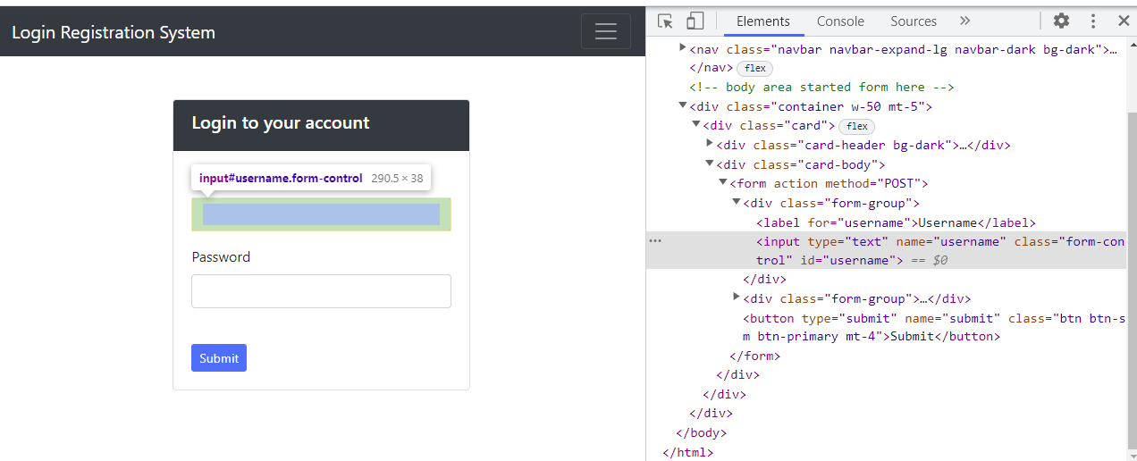
  - Run the file and two test cases should have passed.
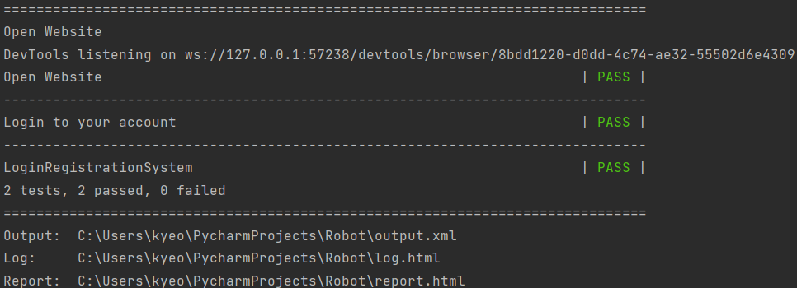
  - After you have login successfully, you should see the page below:
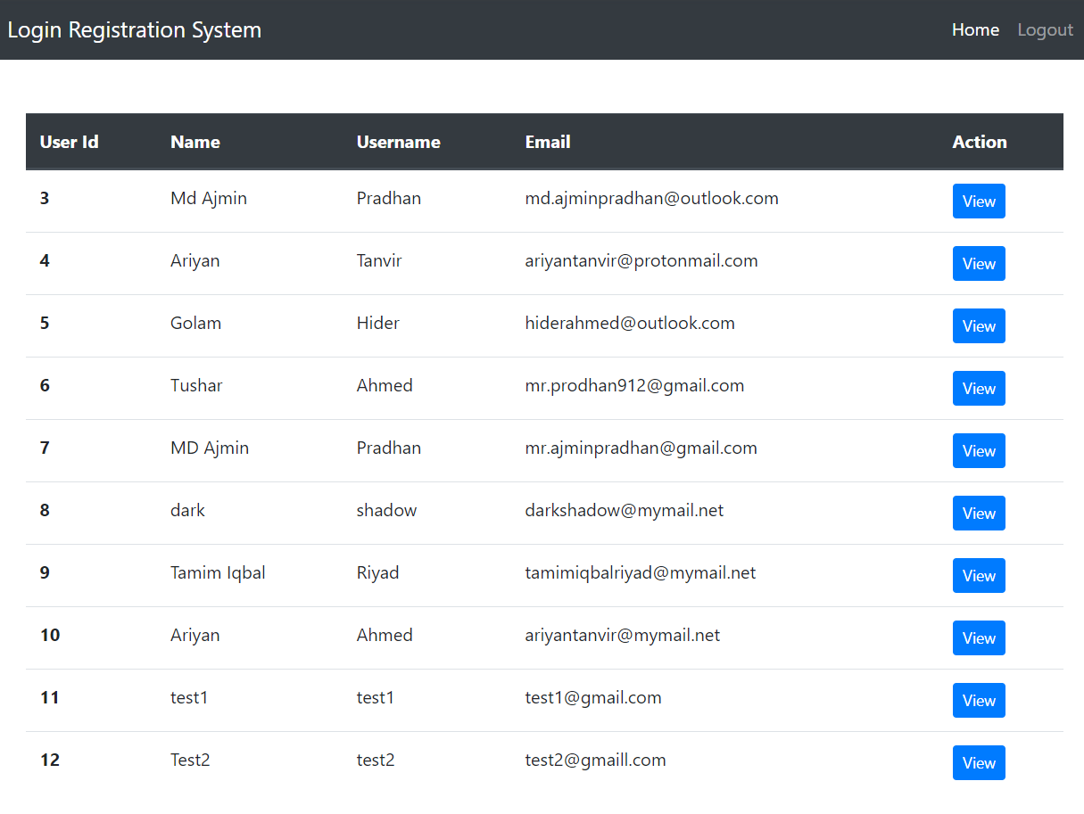
- We will now add in the 3rd test case to logout.
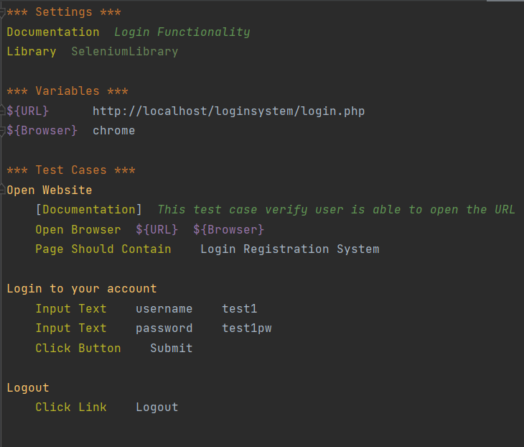
  - Run the file and all three test cases would have passed:
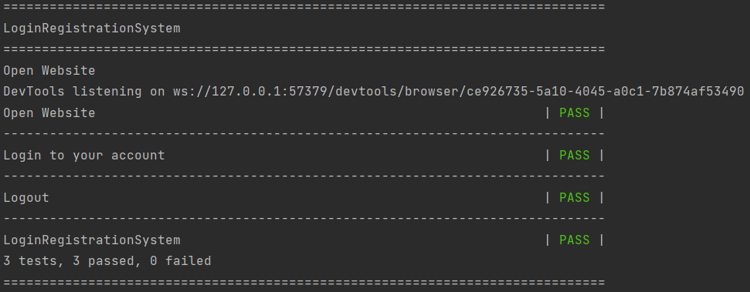
- Now, we will learn about keywords. User-defined Keywords help us to group test steps under a single keyword. So instead of writing multiple lines, again and again, we can just write the keyword once. This helps a lot when you have multiple test cases using the same test steps. It also helps in making the test cases clutter-free and more readable, avoid writing repetitive code, and also helps in code maintenance.
Think of keywords in Robot Framework as functions in other programming languages. Keywords can accept zero or more arguments. You can read more about keywords in https://robocorp.com/docs/languages-and-frameworks/robot-framework/keywords

  - Add *** Keywords *** and the following details:
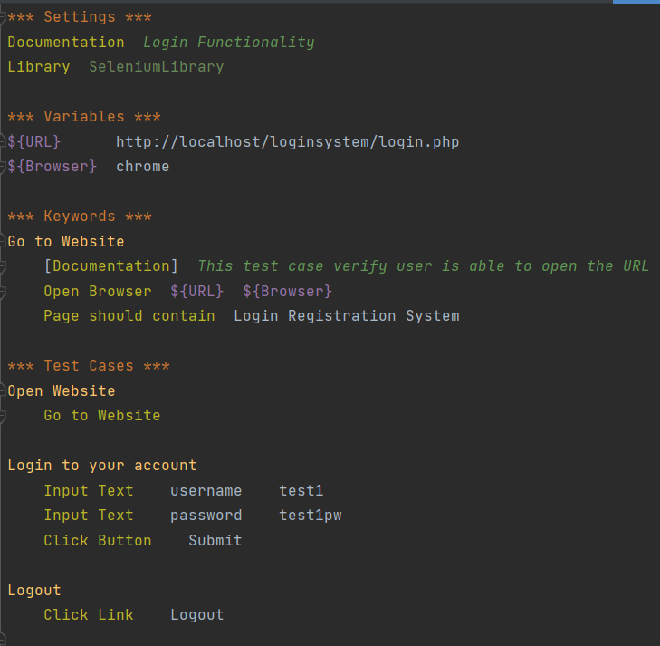
We can now use the keyword “Go to Website” in the test case “Open website”. Run the file and all three test cases should have passed.
- Now, we are going to use setup and teardown. A test setup is something that is executed before a test case, and a test teardown is executed after a test case. Not only test cases but also test suites can have a setup and a teardown. A suite setup is executed before running any of the suite's test cases or child test suites, and a test teardown is executed after them.
  - More information on test setup and teardown can be found at: https://robotframework.org/robotframework/latest/RobotFrameworkUserGuide.html#test-setup-and-teardown
  - More information on suite setup and teardown can be found at: https://robotframework.org/robotframework/latest/RobotFrameworkUserGuide.html#suite-setup-and-teardown
  - For this example, we are going to use suite setup and teardown to go to a website and to close the browser respectively. We can now remove the test case “Open Website”.
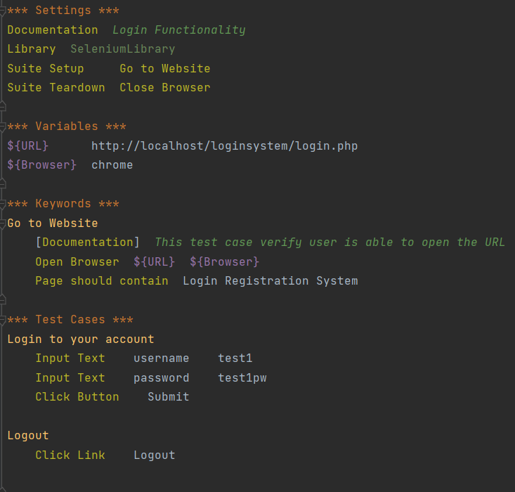
- Run the file and two test cases would have passed.

- Next, we will add in a new test case to view and update details after logging in. After you have login, you are presented view button to update details for a particular user.

- After clicking the view button, there are 5 data fields that we need to enter to update the details:
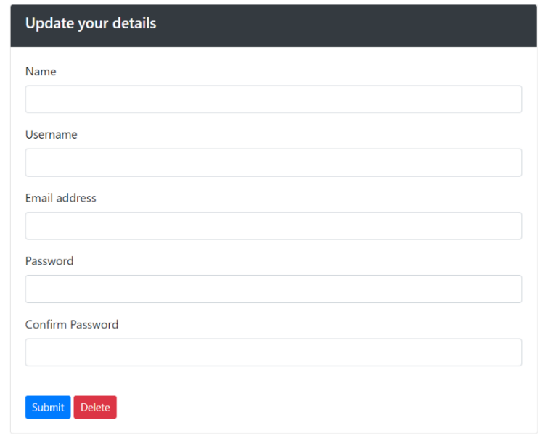
- Before we setup the new test case, we will use a new keyword “Update your details” which takes in 5 arguments as follows:
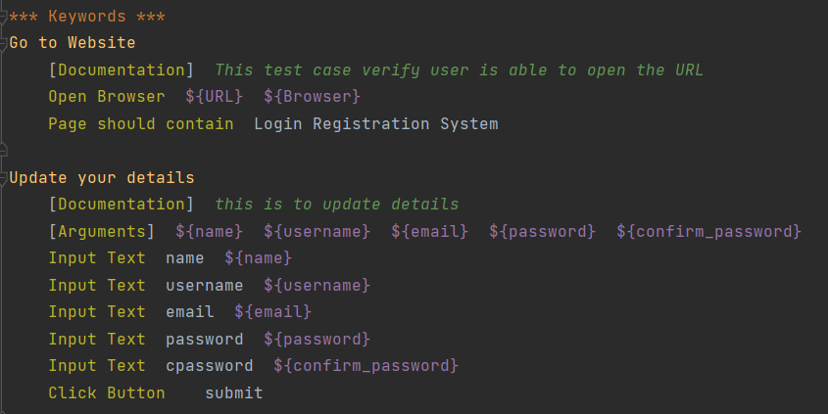
- These 5 arguments correspond to the 5 data fields that we need to enter to update the details.

- To select the view button of a particular name, you will need to identify the row <tr> and cell <td> in which the button resides. The view button for username: test1 in this example is highlighted below:
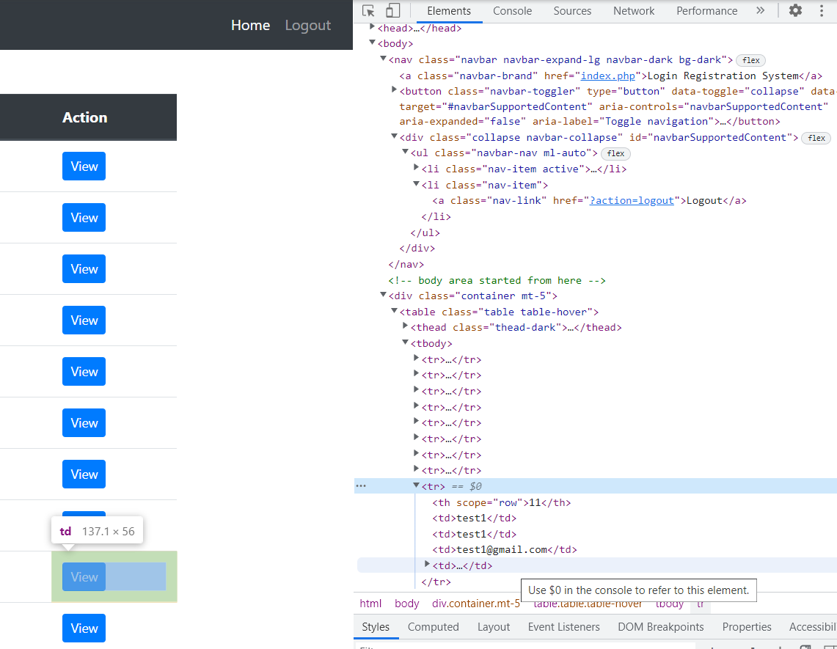
td = 4
tr = 9
- We can then create the new test case “View and Update Details”
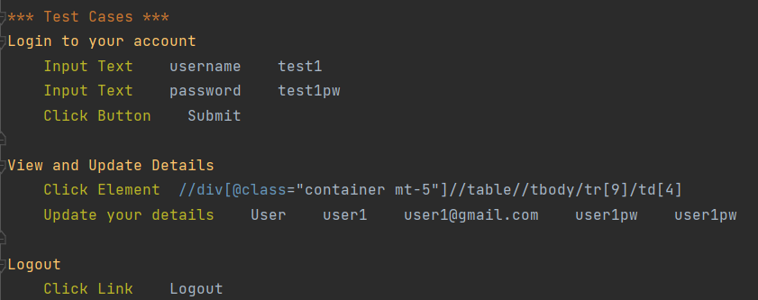
  - Now, run the file and all three test cases should have passed.
(For MAC user, if the test fails because the view button is not clicked automatically, you can try
“Click Element //div[@class=”container mt-5”]//table//tbody/tr[9]/td[4]/a”)

- You can also set the speed of selenium as shown below:
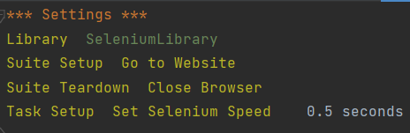

- Finally, the test cases can be further improved to improve their readability. To do that, we will create 5 more keywords as shown:
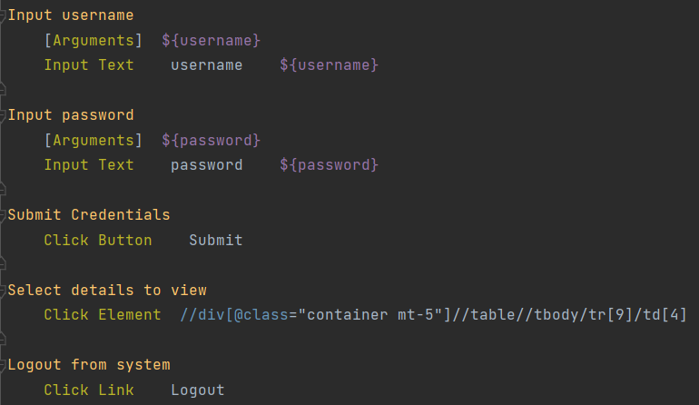

The test cases can now be updated to:
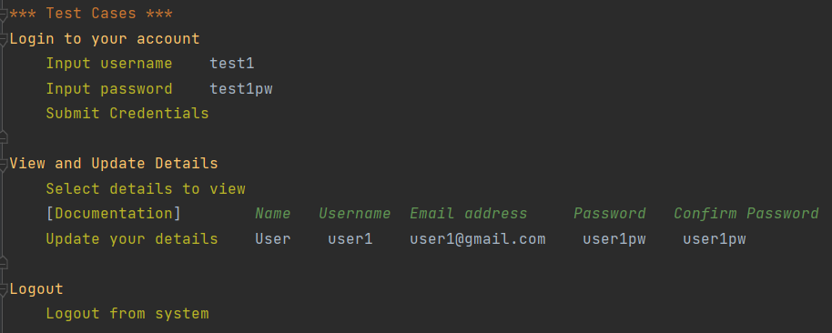

- Lastly, to wrap things up. We can create a new robot file “LRS_Resources.robot” and insert the codes for variables and keywords there. Resource files are imported using the Resource setting in the Settings section. The path to the resource file is given as an argument to the setting.

More information about resource file can be found at https://robotframework.org/robotframework/latest/RobotFrameworkUserGuide.html#resource-files

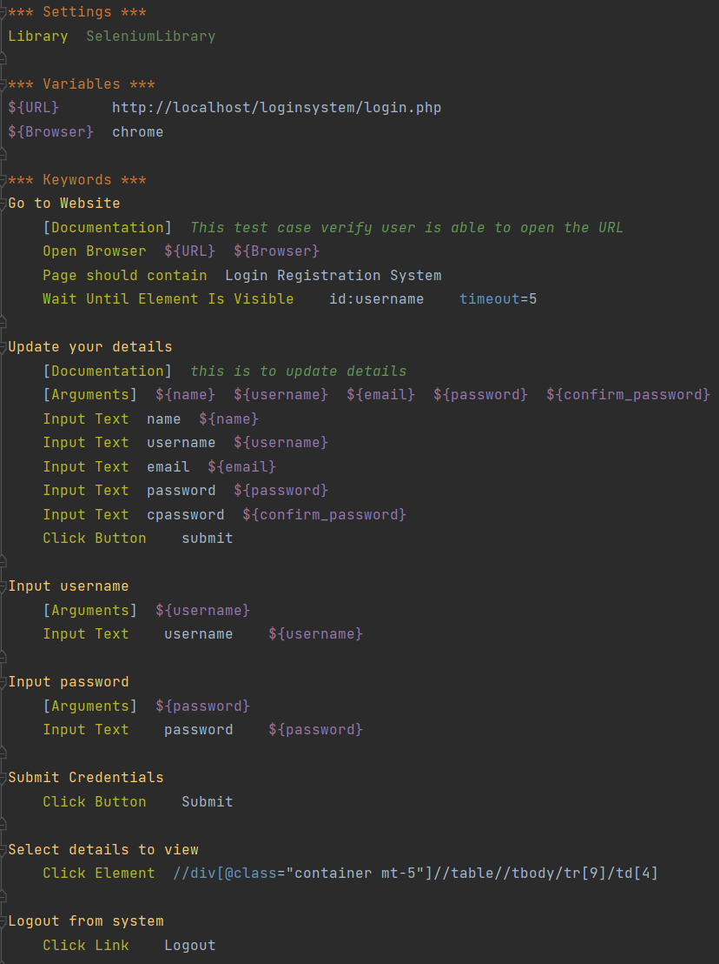

  - Your main program will look less messy now with only settings and test cases. The only thing to remember is to call “Resource LRS_Resources.robot” in your settings.
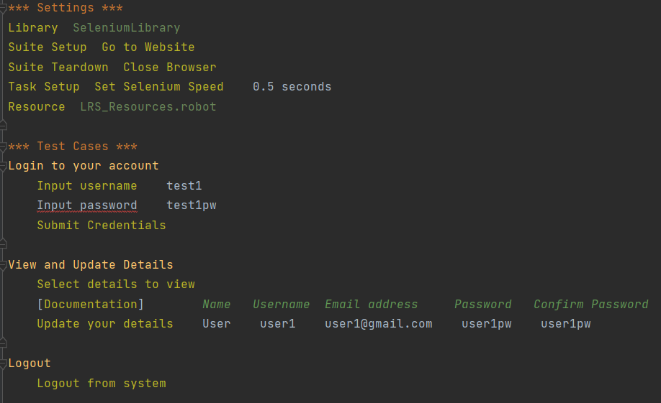
Note: you will not be able to update the details as the system will output “email already exist!”. This is just how this system was programmed. With that, you should have learnt about the basic of Robot Framework and can proceed with the task below:
Tasks:
- You are to use Robot Framework to perform automatic testing for this website: https://petstore.octoperf.com/
  - You should have at least 5 test cases to complete the following tasks:
    - Go to Website and Enter Store
    - Register New Account and Login
    - Buying Fish
    - Proceed to Checkout and Payment
    - Sign Out and Close Browser
  - Setup necessary keywords and variables for the 5 test cases above.
  - Please note: The username was randomly created by generating random string so that all test cases can always be run all the time. Otherwise, once you have created an account using a particular username, you cannot create another account using the same username.
  - You can also view a short demo on robot framework for this task on Learnline > Week 7 > Tasks. There is no sound for this recording, this is just to show how automation can be done using Robot Framework. The program was run twice – the first time at a normal speed and the second time at a very fast speed.
  - You will need to search up on how to select from a dropdown list and clicking on an image. Some useful links:
    - Selenium Library: https://robotframework.org/SeleniumLibrary/SeleniumLibrary
    - Xpath cheatsheet: https://devhints.io/xpath

Useful Links:
Some online resources to help you to understand Robot Framework
- Writing your first test in robot framework: https://testersdock.com/first-test-robot-framework/
- An End-to-End Robot Framework Tutorial: https://codoid.com/automation-testing/an-end-to-end-robot-framework-tutorial/
- Video on introduction to robot framework: https://testautomationu.applitools.com/robot-framework-refresh/
- Exercises on Robot Framework: https://gitlab.com/bftft/robot-framework-testautomationu

